Special Needs Ministries
A Mission Appeal
A Not So Obvious Mission Field
General Conference Session 2015
San Antonio, Texas
July 4, 2015
Presenter: Larry R Evans, DMin
Coordinator of Adventist Deaf Ministries International (ADMI) and
Associate Stewardship Director for the General Conference

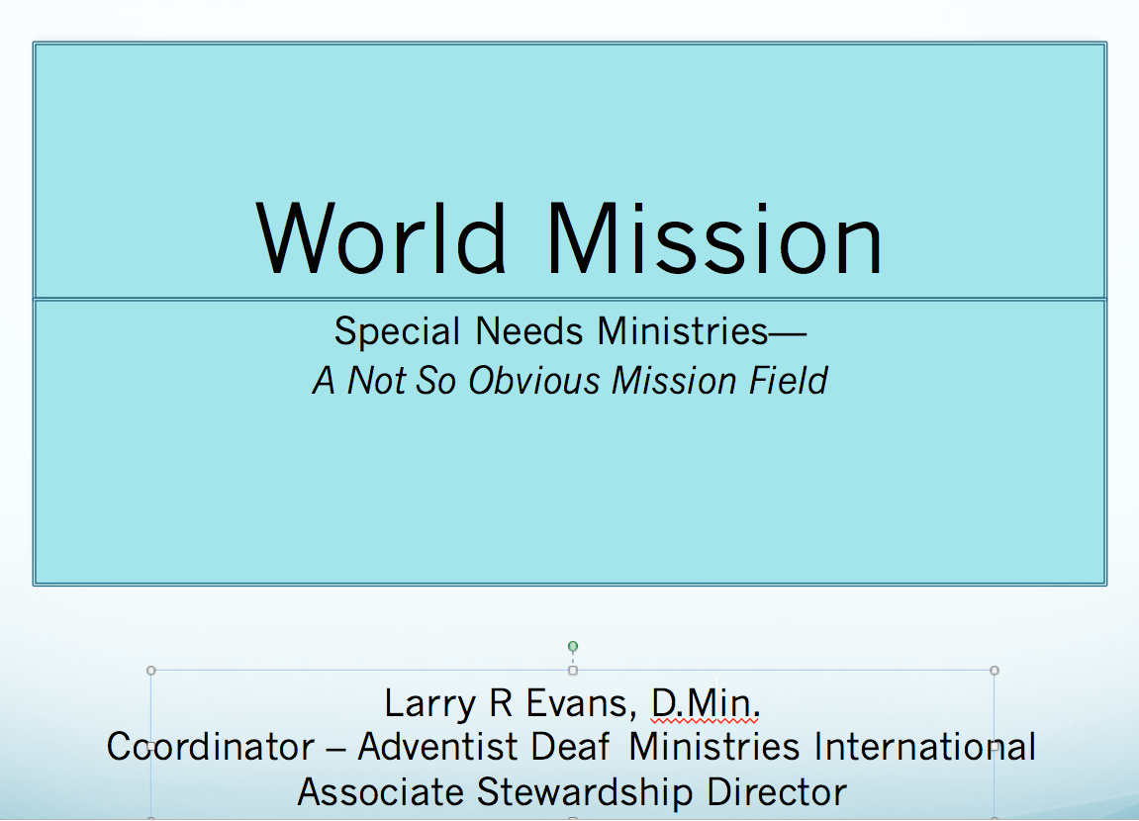

The 18th century German philosopher, Johann Herder, observed that, “We cannot know ourselves without a reference point outside ourselves.” Last year I had one of those reference points firmly established in my mind.

I was traveling in southern Africa and stopped for a few days in Lesotho for a speaking appointment. I had asked ahead of time if arrangements could be made for me to visit some Deaf members while I was there. Instead, arrangements were made for me to visit a private non-Christian vocational school—a school for the deaf, blind and those with physical limitations.

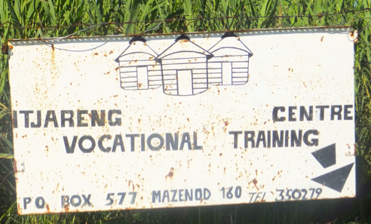

What I did not know until later was that my visit was nearly denied. Another religious group had visited that same school and declared that the problem with these students was that they had evil spirits. The group saw the students as being demon possessed and in need of being exorcised. When we met with the students, I was not aware of the earlier visit. So I began by explaining that I had come to assure them that they were very special to God. I also explained that they were created in His image even if they could not see, hear or walk! The look on their faces was one of surprise.

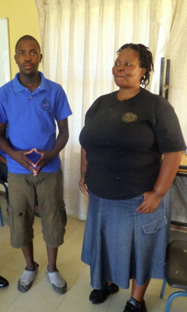

Right after that a teenage deaf boy stood up and spoke through an interpreter. He had just gone to church on Sunday wanting to learn about Jesus. When he got there he was turned away because there was no one to interpret for him. Is it any wonder that only 2% of the 250 million culturally Deaf in the world are NOT Christian! His tears told me how much he wanted to know more about Jesus. He had heard about Him but now he the church doors were closed to him.

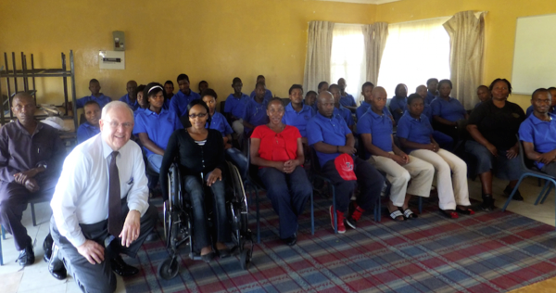

When he sat down a girl in her late teens or early 20’s stood up and spoke in clear English. She began by saying how much they appreciated the fact that we had come to their school and shown a personal interest. She started another sentence but could not finish. She sat down, put her head on her desk and began to cry uncontrollably.

The philosopher had it right: “We cannot know ourselves without a reference point outside ourselves.” That day I had a better understanding of who I was and what we have been called to be and do. I knew then that we can make a difference in the world. But we cannot continue as we have been!

The mission work of the Seventh-day Adventist Church is an important reference point. Having a mission work causes us to look outside our own self-interests. I am convinced that as we minister to others, we will become a kinder, gentler and a more understanding church. Mission work helps take the focus off ourselves so we can see the needs of others. Mission challenges: our perceptions, our prejudices and our pre-conceived ideas of what we think are limitations. If we will let it, mission outreach will help us to first seek to understand others before we ask those living in the world to understand us. That principle can be life changing.

Soon after the General Conference Session of 2010, a committee was formed called Special Needs Ministry Committee. It was originally going to be called Disability Ministries but some spoke up against this. After all, who among us wants to be known for what we cannot do! I am pleased to say our Church is beginning to understand. Respect is beginning to be shown in new ways for those with “Special Needs.” Often it is like working with another culture but this group is not asking for “sympathy”.

It has become clear that the blind, the Deaf and those with physical limitations should not only be recipients of our missionary endeavors; they should also be given opportunities to become missionaries as well! Our definition of what a missionary is can be too restrictive. Crossing a cultural barrier can be as difficult as crossing an ocean. In fact, it is not necessary to cross an ocean or a country’s border to be a missionary nor must one have the ability to see, hear or walk. God is calling all to His service in order for all to be reached!

Special Needs Ministries has extended the arm of our global mission work. The Church is expanding this branch of mission work by renewing it commitment to blind, the Deaf and those with physical limitations. In fact Ellen White tells us that God is testing our character by bringing to us the orphans, blind, deaf and those with physical limitations!

THE BLIND

Christian Record Services for the blind has existed since 1889. As a publishing house for the blind it has sought to bring hope and a new kind of vision to those who cannot see. The World Health Organization estimates that there are 314 million who are legally blind. It’s a huge mission.

Hope comes in many forms but Christian Record Services is providing opportunities such as summer camp experiences and a library of printed materials for the blind to read. It serves over 20,000 blind.

No doubt about it, more needs to be done globally but we already have the foundation to launch massive work for the blind around the world.

THE DEAF
In some areas of the world the Deaf have nearly been forgotten but not everywhere. Today, each of our 13 world divisions has appointed a coordinator to help expand the Deaf work. So much needs to be done!

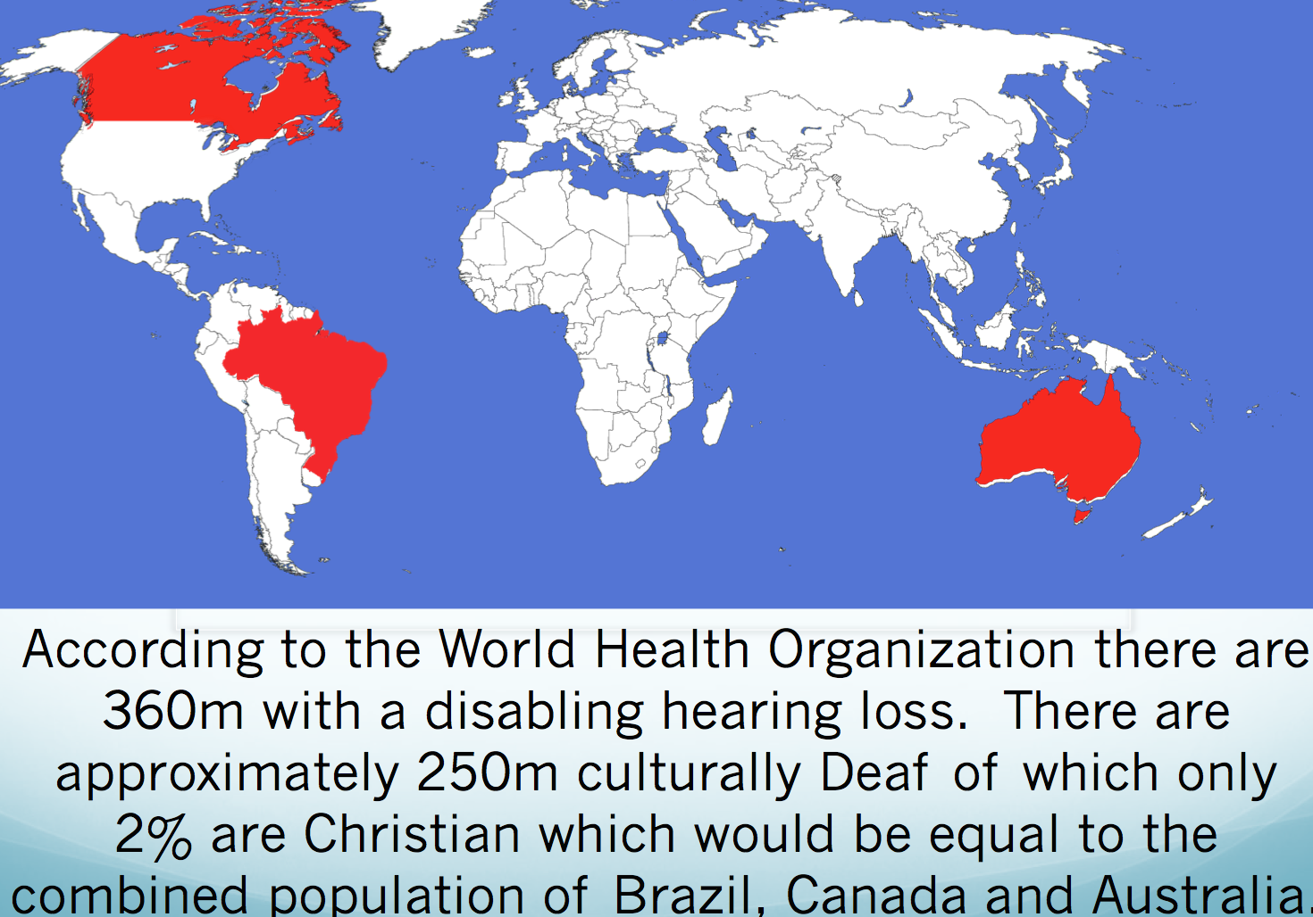

The World Health Organization estimates that there are 360 million who have a disabling hearing loss and of that number approximately 250 million are culturally Deaf—those who have their own unique culture. Many can only be reached by crossing a cultural barrier. The number of unreached culturally Deaf is equal to the combined population of Brazil, Canada and Australia.

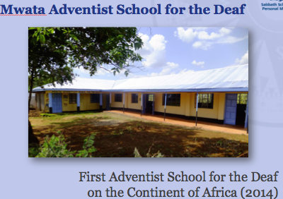

Right now we have 3 denominationally sponsored schools for the Deaf: one in India, one in the Philippines and a brand new one in Kenya – East Central Africa.

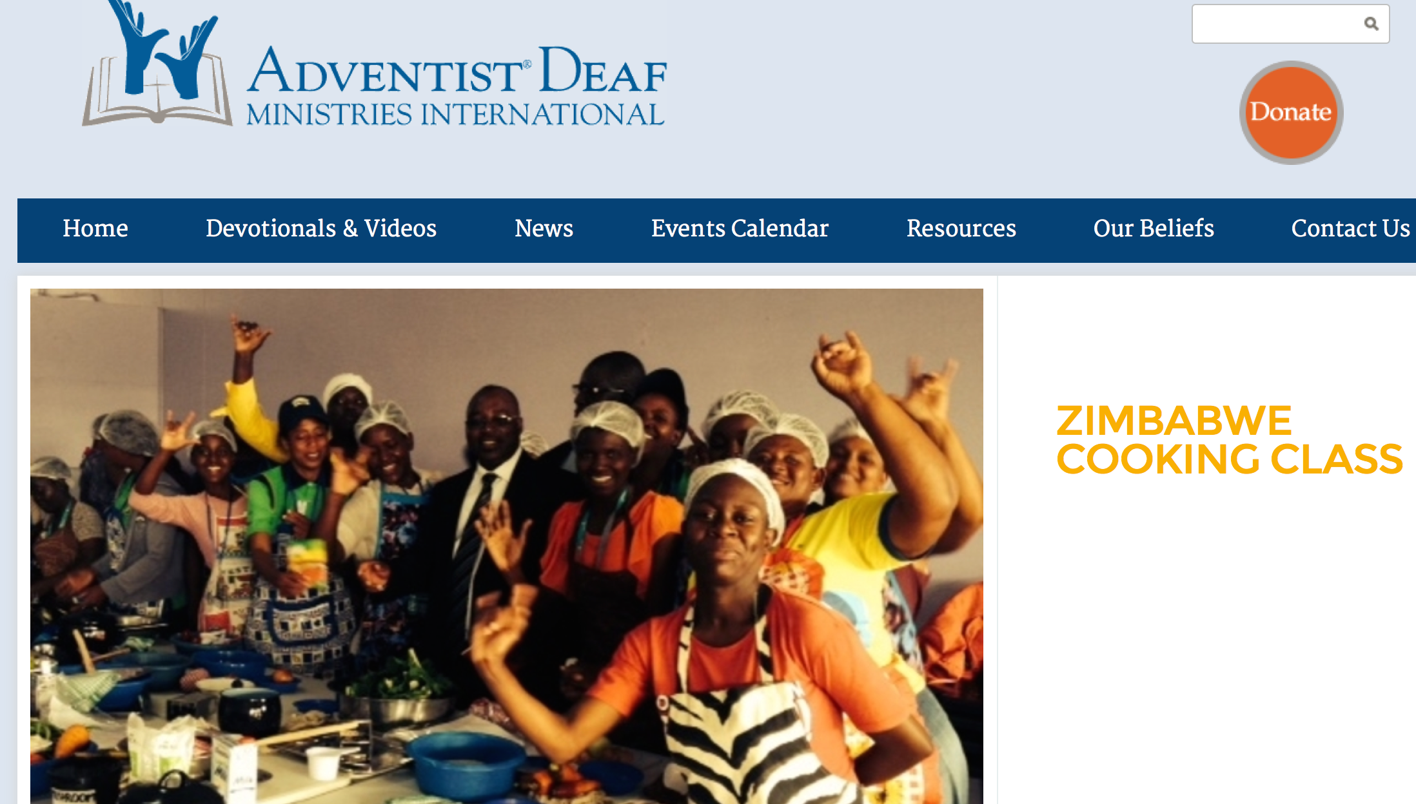

A few months ago a global website for the Deaf was launched and this has helped bring about a sense of identity and a feeling of inclusion.
Major initiatives to reach and train the Deaf are beginning to emerge in some divisions for which we are very grateful.

Today for the first time in the history of our church, Deaf around the world are viewing this Sabbath service with live interpretation. It is being broadcast from right over there! Thank you Hope Channel for your part in this.
I would also like to announce that beginning November 1 there will be a new Internet channel for the Deaf called Hope Channel Deaf!

Much more could be said but one principle has become clear: Where there are changed perceptions, where there is a persistence to reach the unreached and where there is a determination to proclaim hope to all people, things do change. Hope grows and the gospel flourishes.

But we must move on for compassionate ministries must not be limited to just the blind and the Deaf.

THE PHYSICALLY LIMITED

I would like you to meet Joan Bova. Joan was not always confined to a wheelchair. At the age of 12 she was diagnosed as having juvenile arthritis. Once very active she is now and has been for decades confined to a wheelchair.

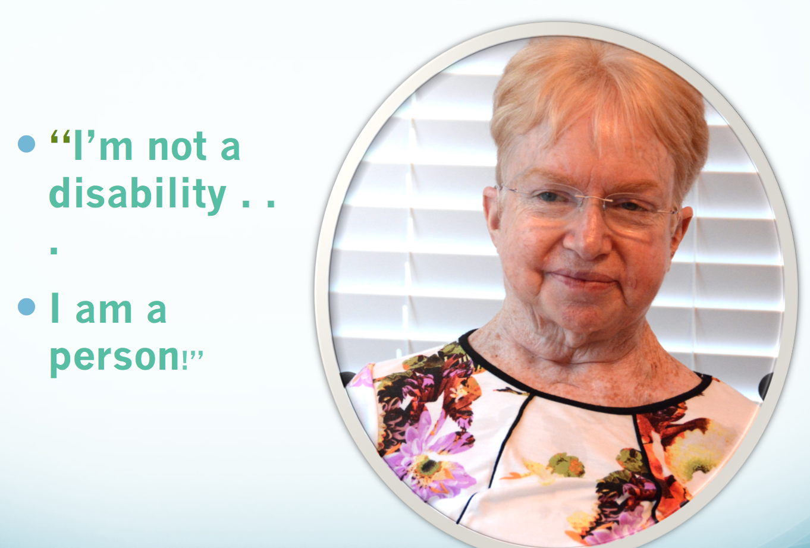

I recently interviewed her. I was blessed and challenged by that interview. She sought no sympathy. She did not blame God. She is a pillar of faith regardless of her circumstances. She did, however, make one point very clear: “I am not a disability! I am a person.” With a smile in her voice she said, “I am not arthritis! I am Joan Bova.”

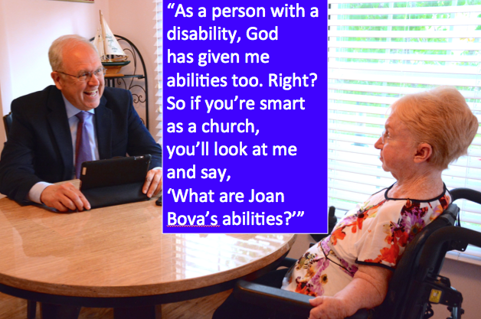

She went on to explain: “As a person with a disability, God has given me abilities too. Right? So if you’re smart as a church, you’ll look at me and say, “What are Joan Bova’s abilities?” You see, Joan also wants to serve and those opportunities are sometimes limited because some think she is best served with sympathy. She put it this way,

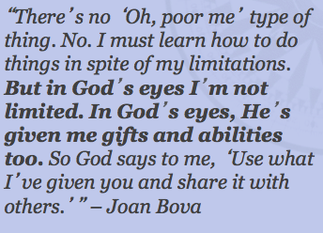

“There’s no, ‘Oh poor me’ type of thing. No. I must learn how to do things despite my limitations. But in God’s eyes I’m not limited. In God’s eyes, He’s given me gifts and abilities too. So God says to me, ‘Use what I’ve given you and share it with others.”

And that’s the message I wish to leave with you today! Whether they be blind, Deaf or physically limited, they too have abilities. We need to make room for them at our meetings, in committees where mission strategies are made. We must let their voices be heard as we lay aggressive plans to reach the world. What they have to share just might surprise us.

The question remains, “Is there room at the table for those with ‘special needs?’” I think so!

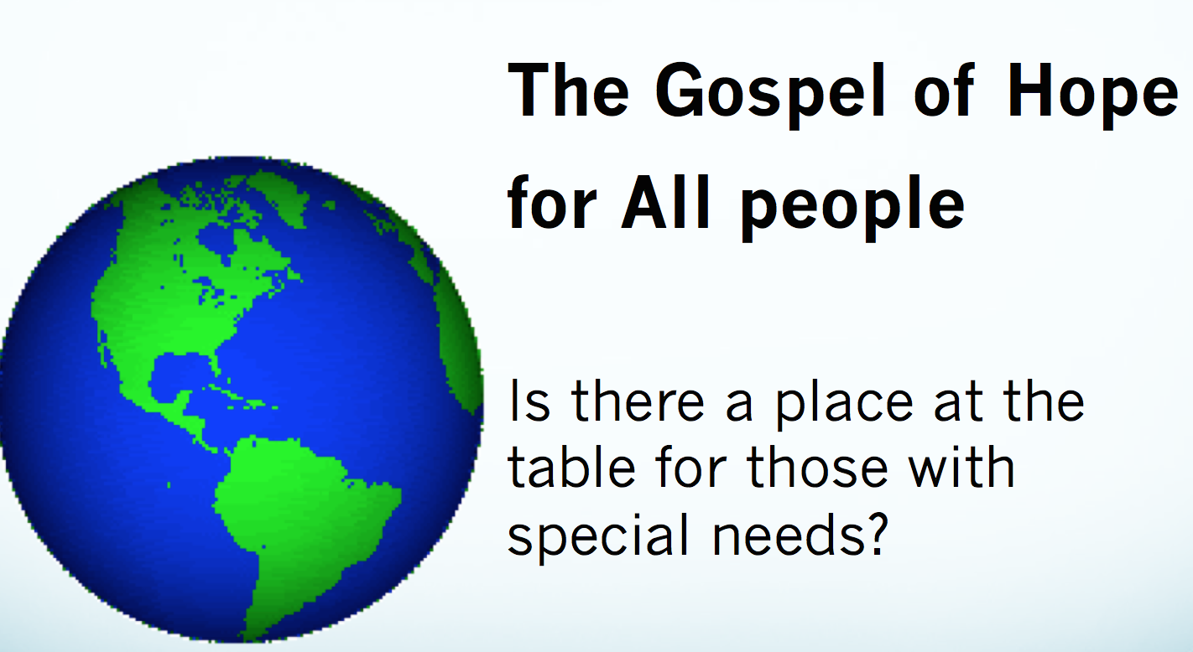

Our mission appeal is threefold:
- Our faithful and generous mission offerings are needed and appreciated.
- We need to become aware of those with special needs around us and then befriend them.
- We must include the blind, the Deaf and those with physical limitations as participants when planning mission strategies. They are part of our missionary team. They not only need us: We need them!

We can begin by first examining our perceptions and then make sure that representatives of all people have a place at the table to plan and to do the mission work of the Church.

